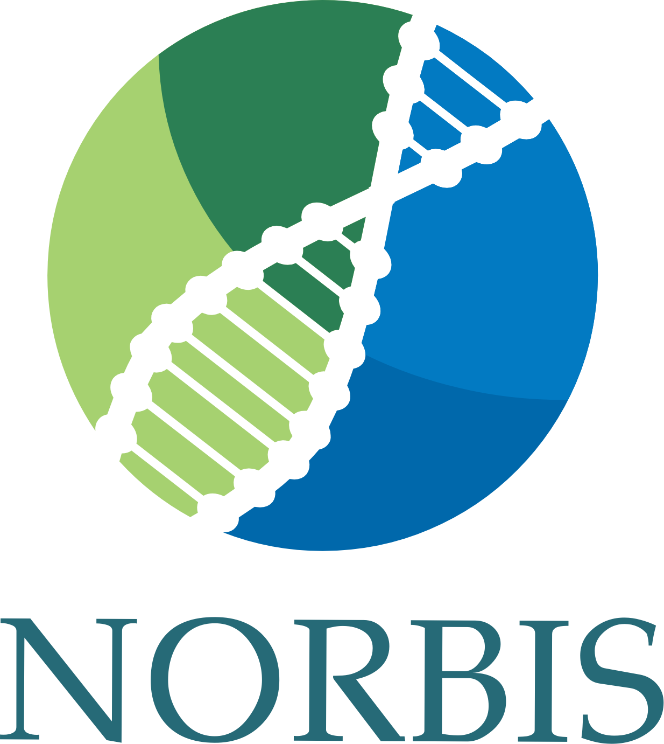
Application to NORBIS
internship program

Your name:

Your email address:

Your affiliation:

Your supervisor:

Title and short description (max 100 words) of your PhD project:

When and where do you plan your internship (host institution, group, contact person)?

What is the purpose of your internship (max 100 words)?

Please provide start and end dates of your PhD project:

How will the internship fit into your PhD plan?

How will the internship benefit your career path (max 300 words)?

Please provide a detailed estimate of the budget, including costs of travel, accommodation and other costs, including other sources of funding:

Please add a short CV (1-2 pages maximum)

